Simplification: H0

BUG 1:

**Tracing**

**H0: Overdue fine is infected after line 90 in ReturnItemControl.Dischargeloan**

**T0: check loan fines state after line 90 before line 91**

**R0: False**

**Test screenshots of the buggy code**

**H1: fineowed is infected after the discharge loan statement on line 91 ReturnItemControl.Dischargeloan**

**T1: check patrons current fines state after line 91**

**R1: True**

**H2: Finesowed is infected after incurring fine from overdue if statement on line 218 in Library.dischargeLoan**

**T2: check patrons current finesowed state;**

**R2: True**

**H3: Patron incur fine method is infected on line 102 in patron.incurFine**

**T3: Change the += into a = and check fines owed after statement again.**

**R3: True**

**H4: Loan discharge loan is infected on line 227 library.dischargeloan**

**T4: check patrons fines owed after line 227**

**R4: True**

**H5: Patron discharge loan is infected the same way as incur fine on line 82 in patron.dischargeloan**

**T5: check fines owed after finesowing is modified in the method.**

**R5: True**

**H6: Fines owing is infected on line 82 in patron.dischargeloan**

**T6: change finesowing statement to a = then check fines owing.**

**R6: True**

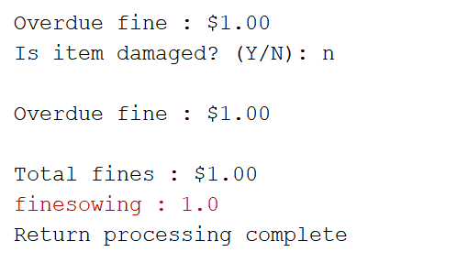

**Bug 2:**

**Simplification**

**H0: Ensure that the if statement line 79 in BorrowitemControl is infected**

**T0: check the if statements calculation before line 79**

**R0: True**

**Test screenshots of the buggy code**

Loan goes past the loan limit indefinitely

**Tracing**

**H0: The < in the infected if statement needs to be a <= in borrowitemcontrol.itemscanned()**

**T0: replace the < with a <= on line 79.**

**R0: True**

**It does enforce the loan limit after the change. It continues to not let the patron borrow.**